Electric Field W.S. Refer to the following information for the next seven questions.

This set of questions is taken from the lesson on electric fields and their properties.

- The region surrounding an electric charge in which another charge will feel a force of attraction or repulsion is call an .

2a. Vectors used to show the location and strength of an electric field are called .

  - They originate on charges and terminate on negative charges.

  - Their direction is defined by the direction in which a test charge would move through an electric field.

  - What units does the Electric field strength measured in?

- a. Like charges repel while unlike charges .

b. The electric field lines between unlike charges are in shape.
- How is the direction of an electric field line defined?

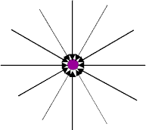

- Is the central "parent" charge in this diagram positive or negative? Look CAREFULLY to "see" the arrows!

positive | negative

- Are the charges shown equal in magnitude? Do they have the same sign?

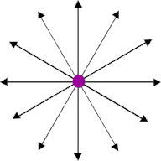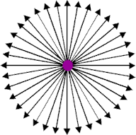

- What does it mean to say that an electric field is "radial?"

- If the field lines in an electric field are parallel to each other, what does this tell you about the electric field strength in that region?

- What does an electric field look like between two charges of opposite sign?

The field lines are elliptical. | The field lines are hyperbolic.

- Which arrow represents the direction of the electric field at point P due to the stationary charges +Q and -Q?
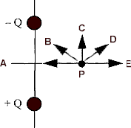

A | B | C | D | E

- What does an electric field look like between two charges of the same sign?

The field lines are elliptical. | The field lines are hyperbolic.

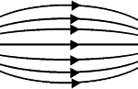
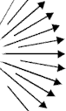
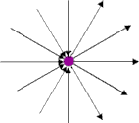
- Which of the four field patterns shown represents a possible electrostatic field?

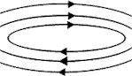

Refer to the following information for the next five questions:

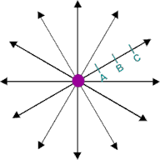
In the following diagram, B is twice the distance from the central charge as is A. C is three times the distance from the central as is A.

- How do the field strengths compare at points A and B?

- How do the field strengths compare at points B and C?

- If the central charge is +3 µC, and point B is 2 meters away, what is the magnitude of the electric field strength at point B?

- What magnitude force would an electron placed at point B experience?

- Would a free proton placed at point B naturally move towards A or towards C?

towards A | towards C

Refer to the following information for the next four questions.

Refer to the following diagram in each of the questions in this set.

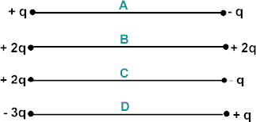

- If each charge group is temporarily connected with a conducting wire, then in which system will the residual charge on each sphere be + ½q?

A | B | C | D

- The electric field intensity is zero at the midpoint of which group of charges?

A | B | C | D

- In which group of charges is the attractive force at the midpoint the greatest? Let the distance between each set of charges be 2r.

A | B | C | D

- Three identical metal balls are mounted on insulated rods. Ball A has a charge of +q, while balls B and C are uncharged. Ball A is brought into contact momentarily with ball B, and then with ball C. At the end of this experiment, how much charge does each ball have?

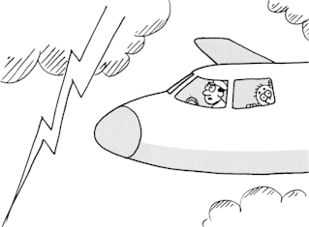

- Are the occupants of an airplane flying in the midst of a thunderstorm in danger of being struck by lightning?
- Why is it not a good idea to seek shelter under a tree in a thunderstorm?
- When it starts to rain, and sometimes before, life guards make everyone get out of a swimming pool. Why is this a wise precaution?
- It is said that there is no absolutely safe place from lightning. Does this apply to astronauts in an orbiting space shuttle or on the moon?

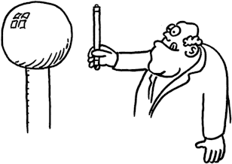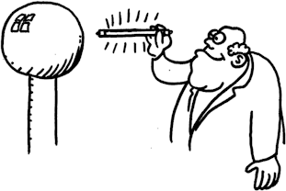

- The lamp will not glow when it is held with both ends equidistant from the charged Van de Graaff generator. But when one end is closer to the dome than the other end, a current is established and it glows. Why?
- Explain why the girl’s hair in the photo stands on end when touching a Van der Graaff Generator. Why is she insulated from the ground?
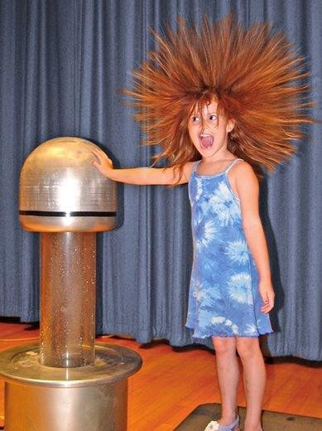
- Would it be safe to get inside a Van de Graaff generator sphere and then have it charges? Explain.

- Sketch the electric field in the vicinity of two isolated . (Don’t forget the directional arrowheads).
- positive charges

- negative charges

- opposite charges

- A net charge on-a-metal conductor resides on the outside of the conductor. Why is this the case?

- Do lightning rods repel lightning? Explain.

- Two metal spheres on insulating rods are in contact, as shown. How would you charge both spheres by induction without directly touching the metal spheres? How would the spheres be charged (positively or negatively)? (Assume you have a rubber rod)
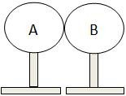
- A student rubs a balloon on her hair and the balloon acquires a negative charge.
  - Explain why the balloon acquires a negative charge.

  - After the balloon is rubbed on the student’s head, the student’s hair stands out from her head. Explain why this happens.

The student then brings the negatively charged balloon near another balloon that was charged in the same way.

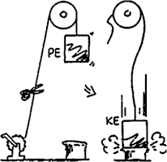
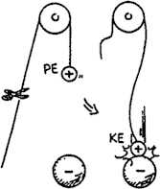
  - Describe and explain what happens when the negatively charged balloon is brought near another negatively charged balloon

Just as PE (potential energy) transforms to KE (kinetic energy) for a mass lifted against the gravitational field (left), the electric PE of an electric charge transforms to other forms of energy when it changes location in an electric field (right).

- REVIEW: When released, how does the KE acquired by each compare to the decrease in PE?

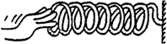
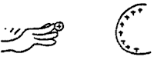
Refer to the following information for the next five questions.
A force compresses the spring. The work done in compression is the product of the average force and the distance moved. W = Fd. This work increases the PE of the spring.

Similarly, a force pushes the charge (call it a test charge) closer to the charged sphere.

- a. The work done in moving the test charge is the product of the average

and the moved. W =
  - This work the PE of the test charge.

  - If the test charge is released, it will be repelled and fly past the starting point. Its gain in KE at this point is to its decrease in PE.

At any point, a greater quantity of test charge means a greater amount of PE, but not a greater amount of PE per quantity of charge. The quantities PE (measured in joules) and PE/charge (measured in volts) are different concepts.

By definition: Electric Potential = PE/charge.

1 volt = 1 joule / 1 coulomb

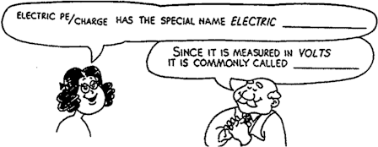

- Electric PE/charge has the special name electric .

- Since it is measured in volts it is commonly called .

- If a conductor connected to the terminal of a battery has a potential of 6 volts, then each coulomb of charge on the conductor has a PE of .

- Some people get mixed up between force and pressure. Recall that pressure is force per area. Similarly, some people get mixed up between electric PE and voltage. According to this chapter, voltage is electric PE per .

- What does a volt measure?

- What is the definition of the absolute potential at infinity?

- For a charged conducting sphere, how do the graphs of E vs r and Vabs vs r compare?

- How do field lines indicate where the strength of a field is greatest?

- How do equipotential surfaces indicate where the strength of a field is greatest?

- What two combinations of units can be used to measure an electric field's strength?

- At what angle do equipotential surfaces meet field lines?
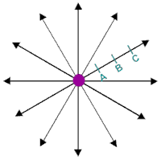
Refer to the following information for the next five questions.

Positions A, B, and C are spaced equally: rC = 3rA.

- How do the absolute potentials numerically compare between points B and C?

- If a positive test charge moves in the direction of a field line, does its EPE

increase | decrease

- Two test charges are brought from infinity into the vicinity of a sphere of charge +Q. The first test charge, +q, is brought to point A; the second test charge, +2q, is also brought to point A. Compared with the electrostatic potential of +q, the electrostatic potential of +2q is

smaller | the same | greater

- Two test charges are brought from infinity into the vicinity of a sphere of charge +Q. The first test charge, +q, is brought to point A; the second test charge, +2q, is brought to point B. Compared with the electrostatic potential energy of the +q test charge at A, the electrostatic potential energy of the +2q test charge at B is

smaller | the same | greater

- Two test charges are brought from infinity into the vicinity of a sphere of charge +Q. The first test charge, +q, is brought to point B; the second test charge, -q, is also brought to point B. Compared with the electrostatic potential energy of the +q test charge at B, the electrostatic potential energy of the -q test charge at B is

smaller | the same | greater

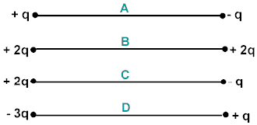
Refer to the following information for the next three questions.

Let the distance between each set of charges equal 2r.
- In which charge group(s) is the voltage at the midpoint equal to zero?

A | B | C | D

- How much work would be required to move a proton from infinity and place it on the midpoint of group B?

- How much work would be required to move a proton from infinity and place it on the midpoint of group D?

- In which charge configuration are both net E and net V nonzero at the center of the equilateral triangle?

- Why must work be done in charging a pair of capacitor plates even without a dielectric between the plates? Why is more work required when there is a dielectric between the plates?
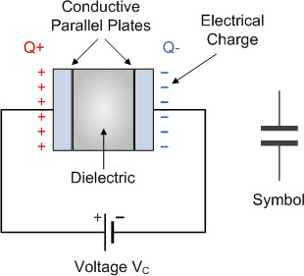
- Why must a capacitor dielectric be an insulating material?

